# ***How to add a process in Eagle Insight Community Edition***



**What is Eagle Insight?**

* Eagle Insight is a cloud based advanced RPA analytics program. Eagle Insight tracks, measures, analyses and supports the performance of your entire automation program.
* Eagle Insight brings Process Insight, Business Insight, Support Insight and BOT Insight all on a single platform.

**Adding a process in Eagle Insight:**

* Go to the website <https://eagleinsight.io/> and click on community edition at the top right.



* Signup or sign in if you already have the account.

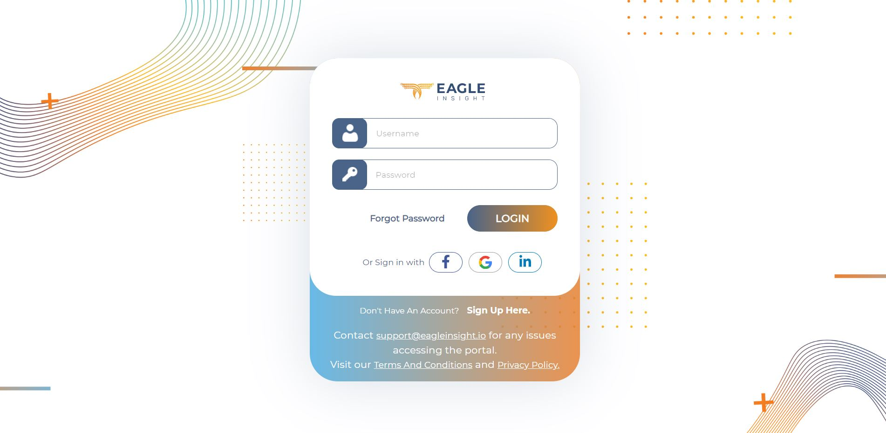

**Here is what you can do with the community edition**:

* ***Create Business Case in Minutes***

Business Insight Dashboard

* Visualize Process ROI
* FTE hours saving
* Cost of Automation
* Payback Period
* ***Prioritize Your Processes***

Process Ranking

* + - Visualize Process Priorities
    - Process Complexity
    - Process ROI
    - Process Suitability
* ***Manage Automation Pipeline***

Process Vault

* + - Manage and Monitor Processes
    - KANBAN view
    - Edit, update, view processes
* Click on **Add Process** after selecting **Process Vault**. Process Vault is where you can keep track of your processes.

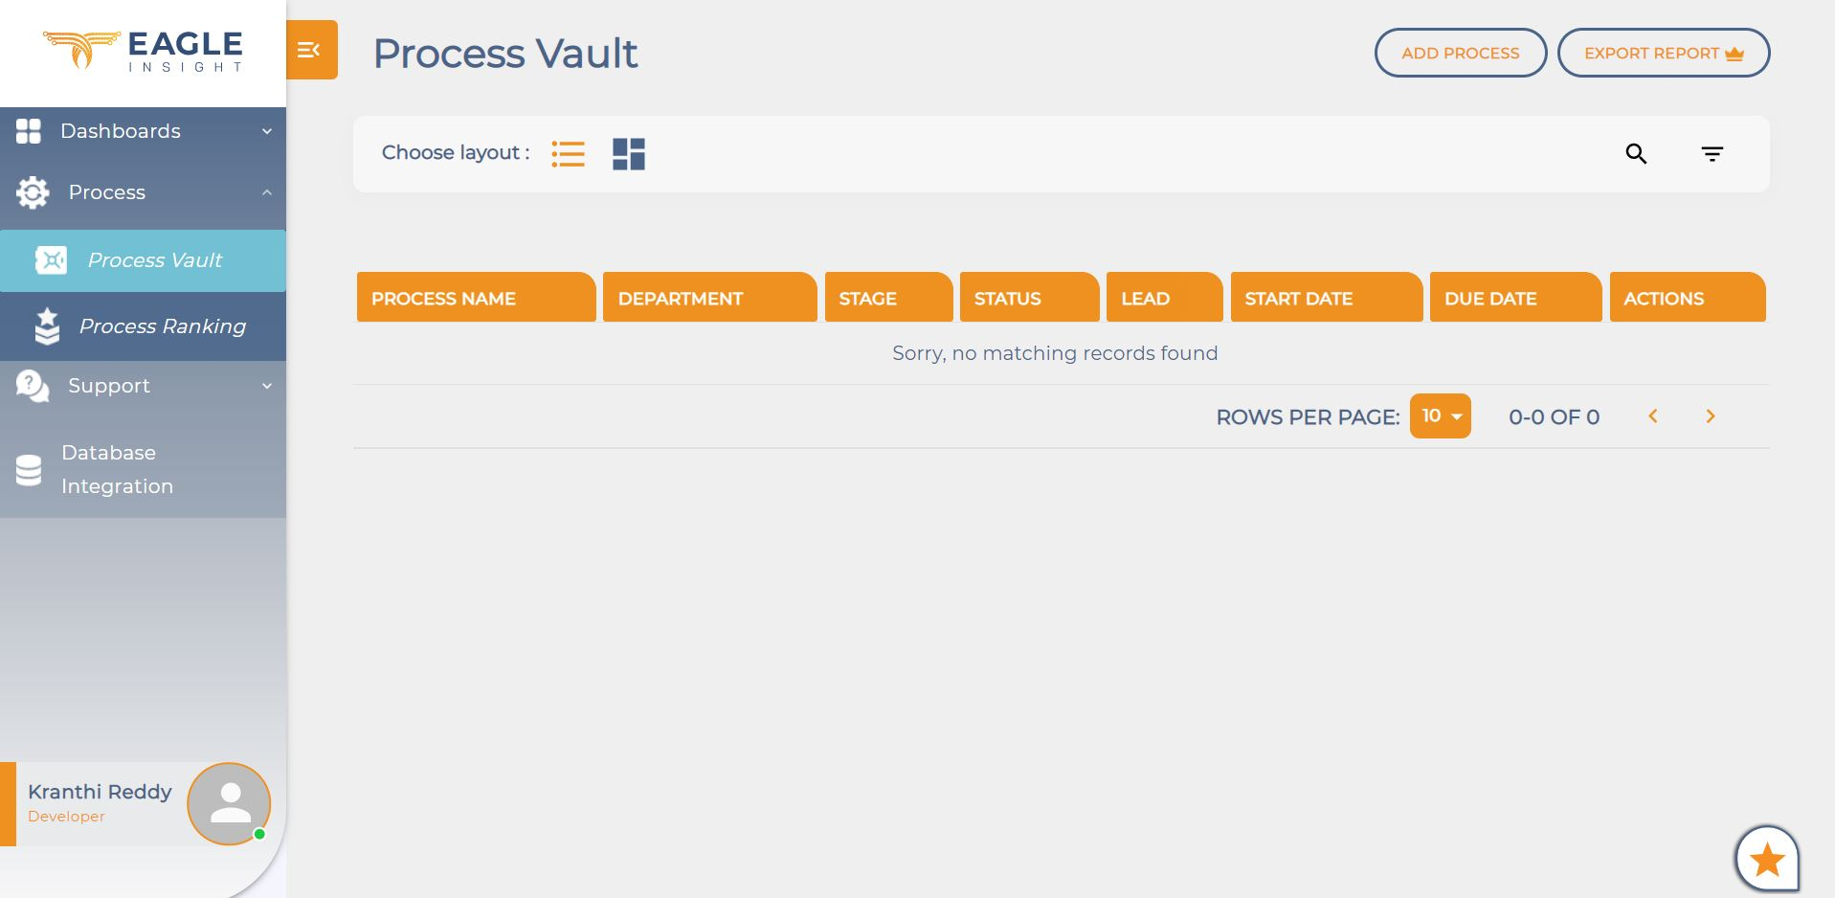

* After clicking on “Add Process”, you have to fill the details which are asked as shown in the below pic:

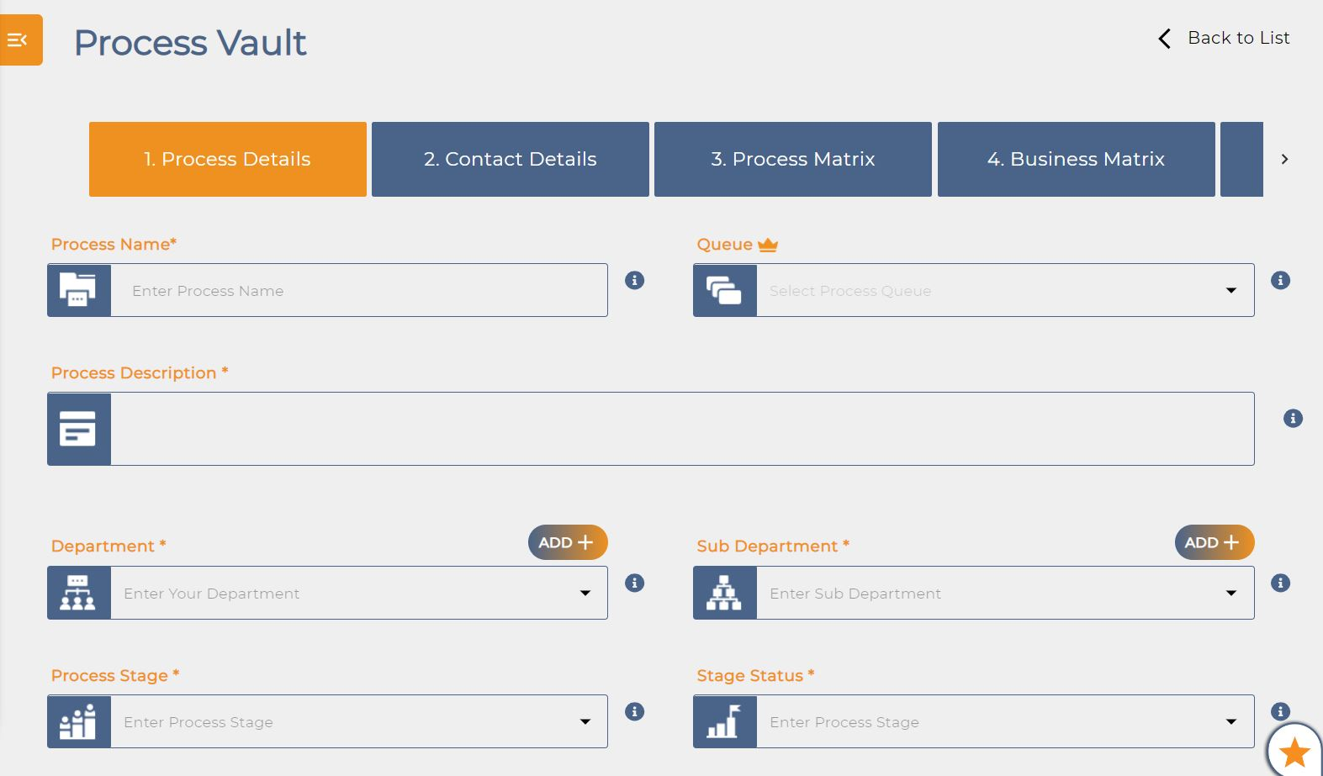

*Process Details:*

* You need to provide Process Name, Process Description, Department, Sub Department, Process Stage, Stage Status, Start Date and End Date. For Ex: In this I take as Oracle Automation as a example.
* In case your department or sub department is not in the list, you can add them and select the particular department you want.

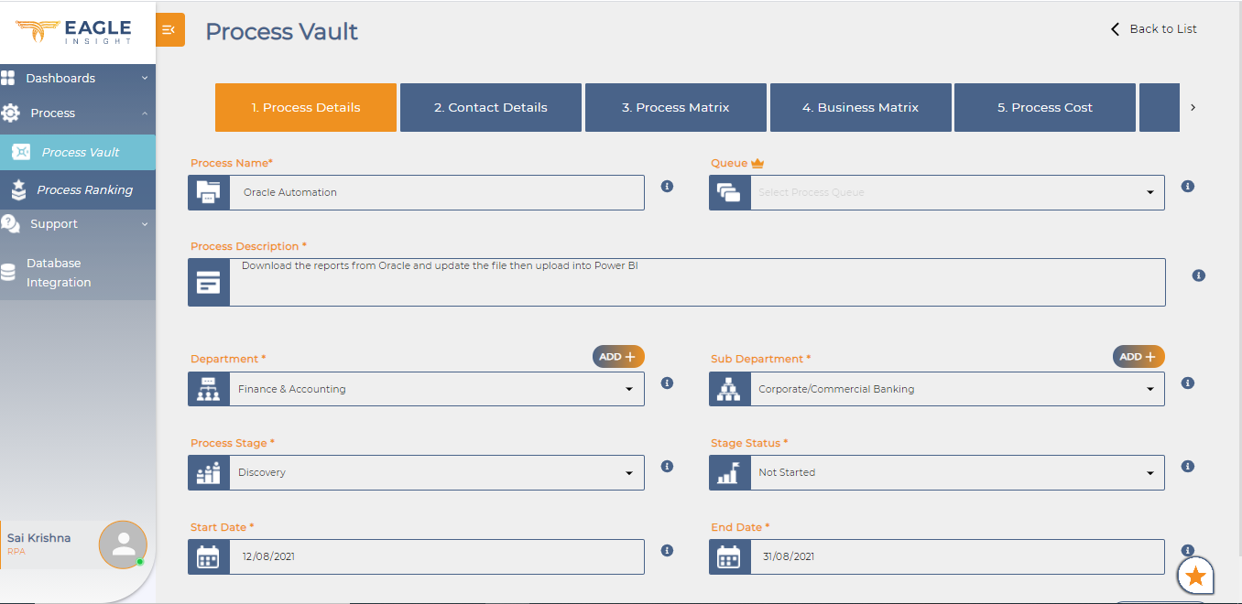

*Contact Details:*

* In contact details, you can give Process Lead, Email, Team Members and contact no.

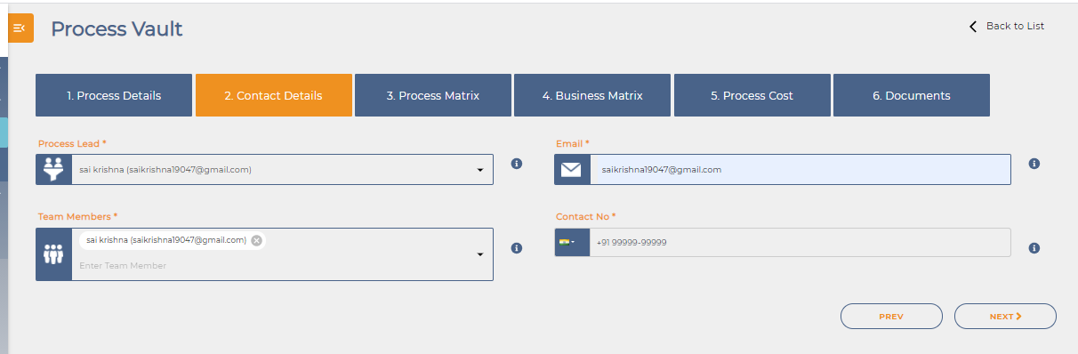

*Process Matrix:*

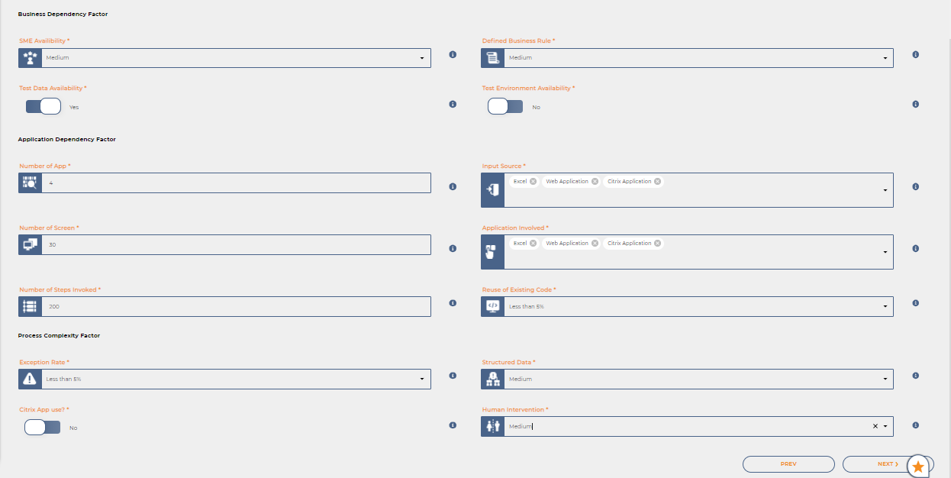

* In Process Matrix, you can give Business Dependency Factors, Application Dependency Factors and Process Complexity Factors.
* Here you give number of apps available, what are the input sources, Number of apps.
* We can give number of steps invoked, reuse of existing code.
* In complexity factor, we have exception rate, structured data and human intervention options.

*Business Matrix:*

* In Business Matrix, you can give details like Benefit Drivers, Once Off benefit, Transaction Matrix, Process Complexity Factors.

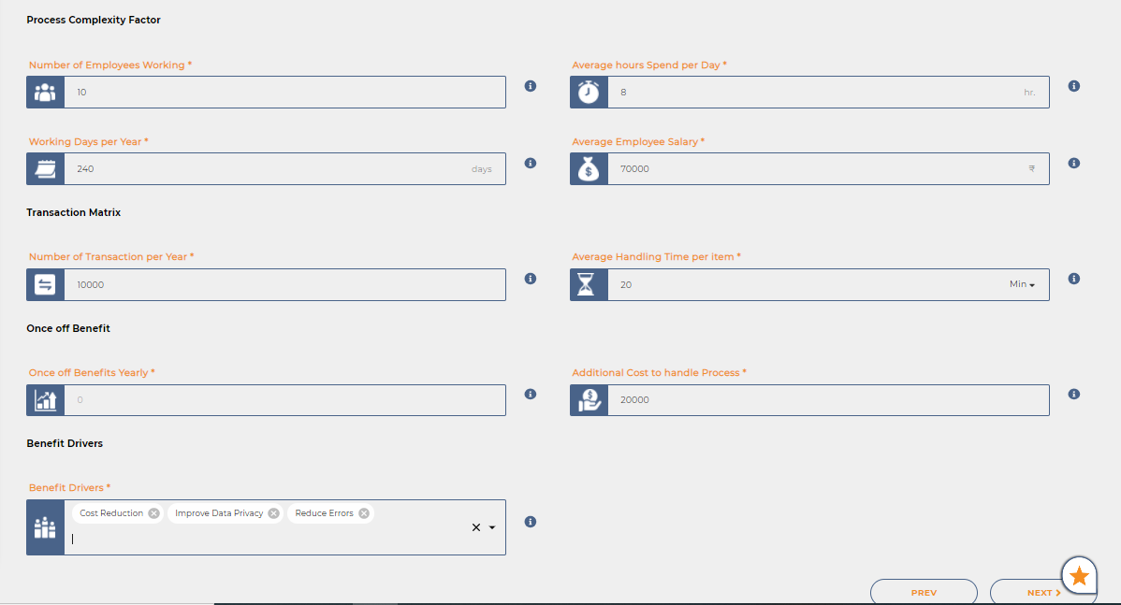

*Process Cost:*

* In process cost, you can give cost type, cost description and total cost. If the cost type is not in the list you can add the type.

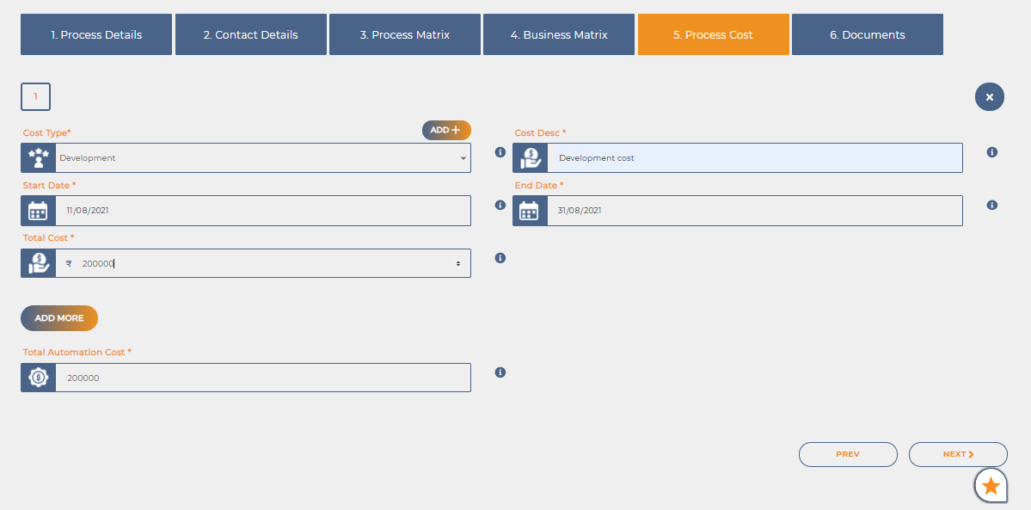

*Documents:*

* If you have any documents regarding the process, you can add them here in this step

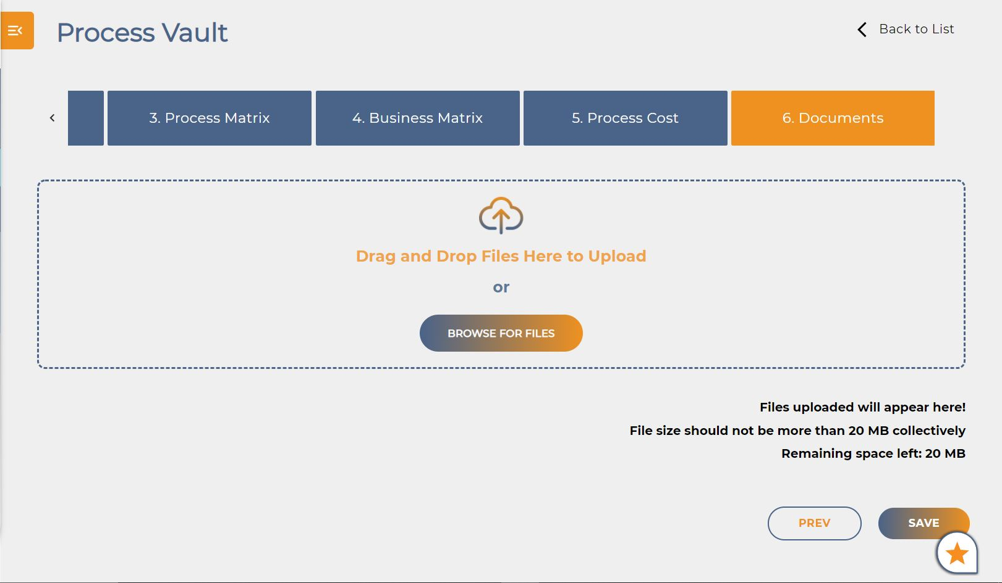

* Click on Save and you can see the process in Process Vault.

Process Summary:

At last, if we need to know the progress of the process. We have to select the particular process and we will observe the progress of process. Please refer below screenshots.

